GAIL - Awareness Program/Seminars on PNG/CGD at Dehradun on 15th March 2022
GAIL(India) Limited organized the 5th Awareness Program (under the aegis of Ministry of Petroleum & Natural Gas) on City Gas Distribution today as part of Azadi ka Amrit Mahotsav celebration on 15.03.2022.
The program was organized through hybrid mode by GAIL (India) Limited. It was organised from ONGC Academy at Dehradun in physical mode wherein senior officers of ONGC and GAIL attended the session and simultaneously program was webcasted among all GAIL & ONGC Employees, Senior officials of MoP&NG, Oil & Gas PSU employees, various CGD customers of GAIL, and also amongst the student fraternity from various universities like Shiv Nadar University, RGIPT, IIPE and UPES. More than 70 attendees attended program in physical mode.
The program started with a brief on the relevance and objective of Azadi Ka Amrit Mahotsav which set the tone for the program. The key note address was delivered by Sh Manoj Bharthwal, ED and Head ONGC Academy. Sh Shashi Rajan, GGM & Head Management Development Group, ONGC Academy also shared a few words to mark the occasion.
This was followed by the awareness sessions.
The session was conducted on “City Gas Distribution- Safety Aspects”. It was delivered by Shri Arvind Bhatia, CGM-Production ONGC. . The hazards associated with the Natural Gas usage and control & mitigation of these recognized hazards were discussed in a very interactive way.
The next session was on “City Gas Distribution- Customer Aspects”. It was delivered by Shri V K Arora, GM-Gail Gas Limited, Dehradun. All the main components of City Gas Distribution was covered in this session.
The sessions were extraordinary and very powerful. It was packed with information and delivered in a very simple and flowing pattern. The session ended with a brief Q & A round which was highly interactive. Dr R S Velmurugan, GM (Training), delivered the vote of thanks to all who made this event happen.
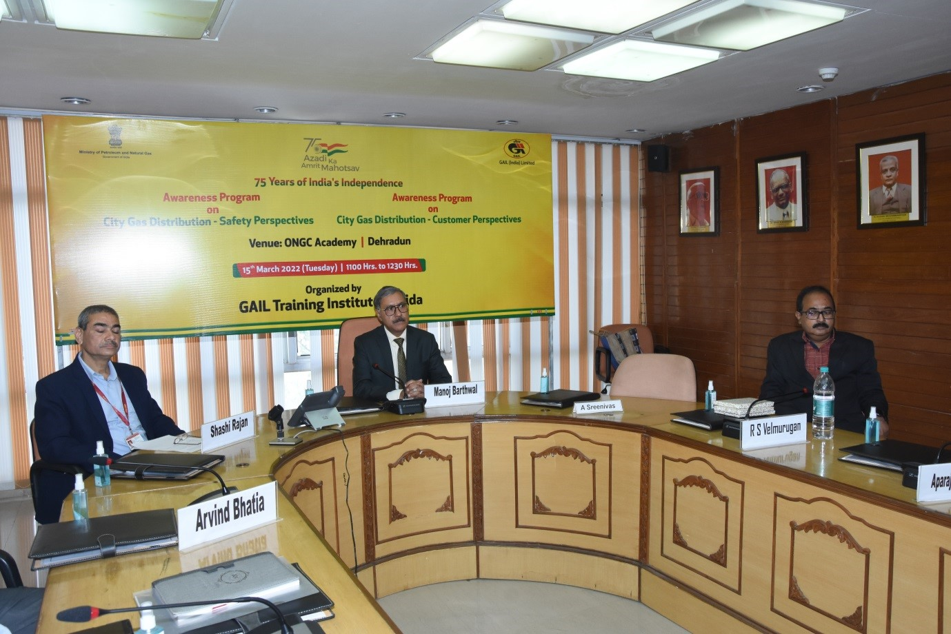
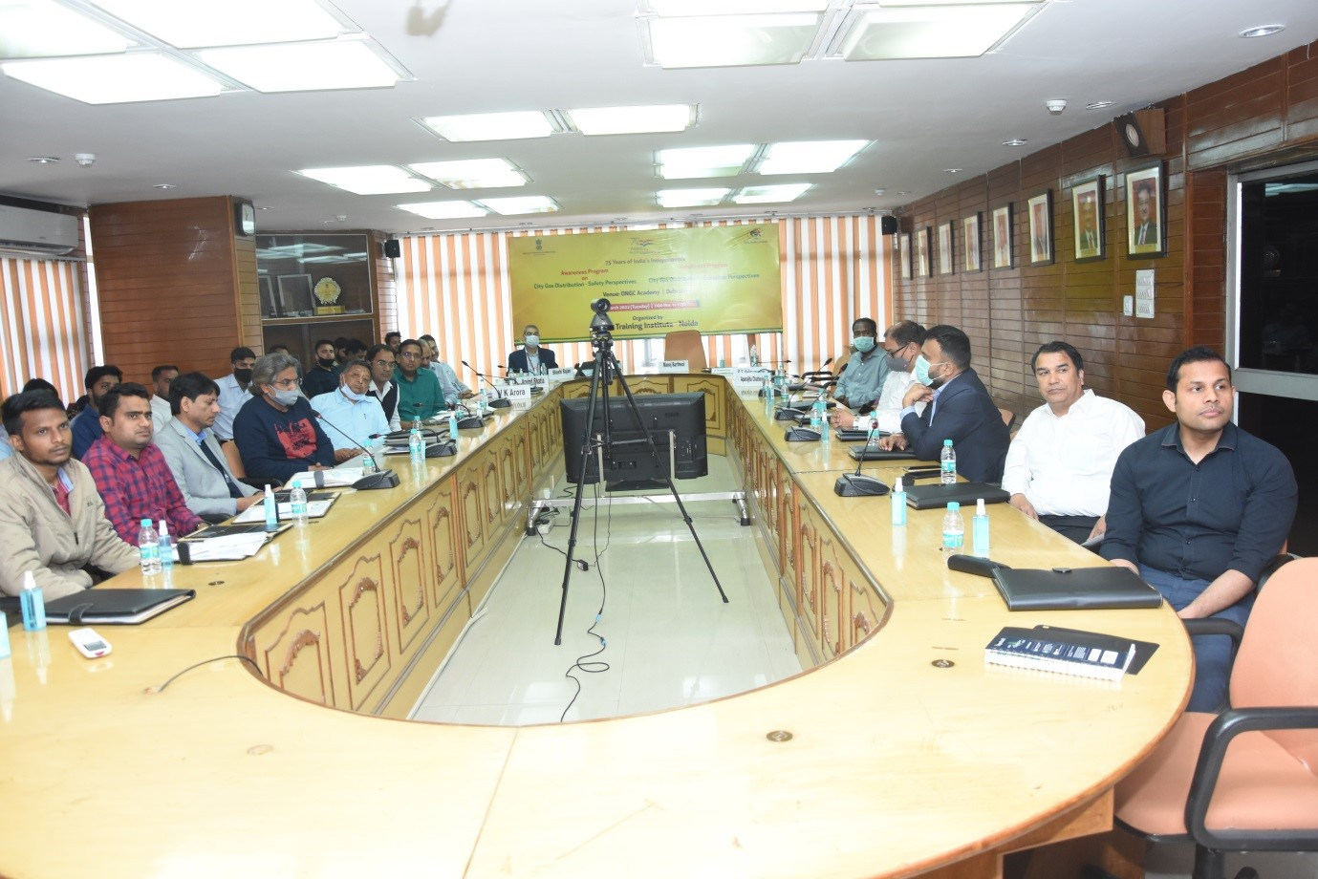
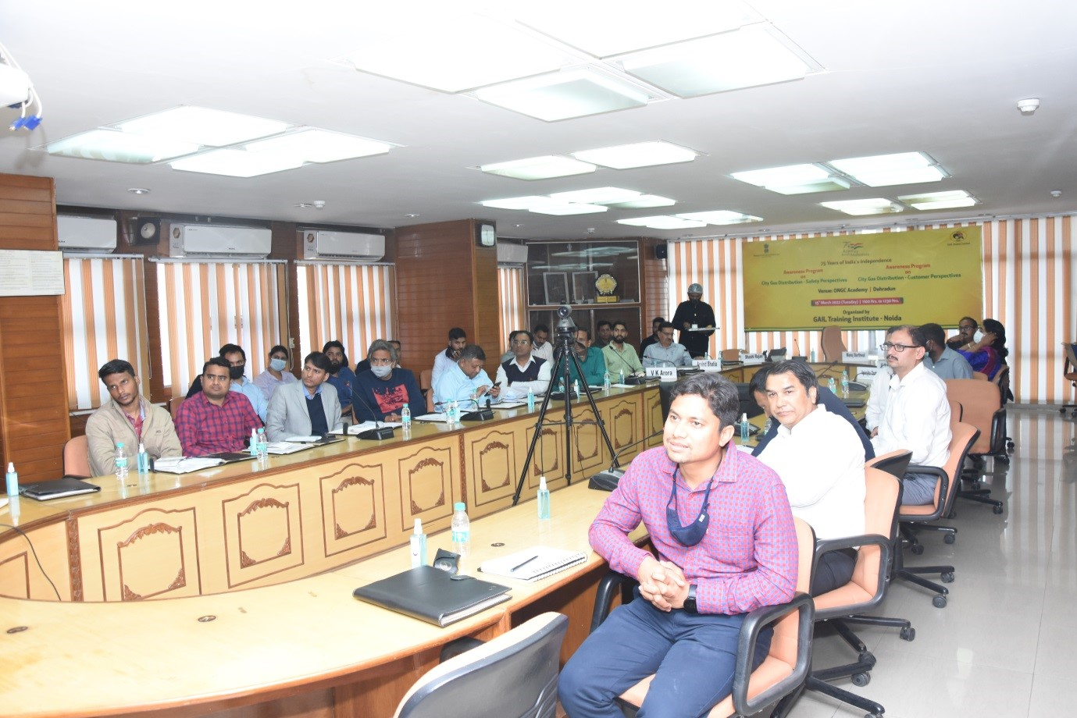

BPCL conducts study visit for students to Mumbai Refinery under ‘Azadi Ka Amrit Mahotsav’ - 11.03.2022

Bharat Petroleum Corporation. Ltd, Mumbai Refinery organized Study Tour for School/College Students to Refinery as part of Azadi Ka Mahotsav – 75 years of Independence Day, under the aegis of the Ministry of Petroleum & Natural Gas, Govt. of India.
Students were briefed about Refinery working by giving a detailed presentation about Mumbai Refinery, Refining process and Technological developments that has taken place over the years. Also, an hour long bus tour to the main units of the Refinery where the students caught a glimpse of how refinery operations are controlled and monitored.
Mr. D. K. Zutshi, DGM (Advance Control & Optimization) MR and Mr. Harshbir Singh Ahluwalia, Manager (Energy) explained Refinery working by giving a detailed presentation about Mumbai Refinery, Refining process and Technological developments that has taken place over the years. The icing on the cake was the hour long bus tour to the main units of the Refinery where the students caught a glimpse of how refinery operations are controlled and monitored.
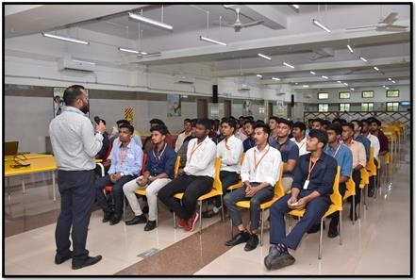

BPCL conducts study visit for students to Mumbai Refinery under ‘Azadi Ka Amrit Mahotsav’ - 13.03.2022

Bharat Petroleum Corporation. Ltd, Mumbai Refinery organized Study Tour for School/College Students to Refinery as part of Azadi Ka Mahotsav – 75 years of Independence Day, under the aegis of the Ministry of Petroleum & Natural Gas, Govt. of India.
Students were briefed about Refinery working by giving a detailed presentation about Mumbai Refinery, Refining process and Technological developments that has taken place over the years. Also, an hour long bus tour to the main units of the Refinery where the students caught a glimpse of how refinery operations are controlled and monitored.
Mr. D. K. Zutshi, DGM (Advance Control & Optimization) MR and Mr. Harshbir Singh Ahluwalia, Manager (Energy) explained Refinery working by giving a detailed presentation about Mumbai Refinery, Refining process and Technological developments that has taken place over the years. The icing on the cake was the hour long bus tour to the main units of the Refinery where the students caught a glimpse of how refinery operations are controlled and monitored.
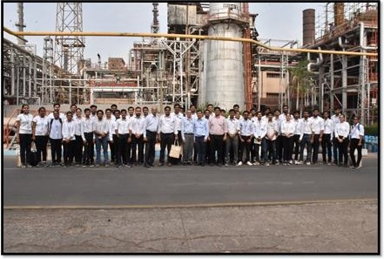

Azadi ka Amrit Mahotsav LPG SurakshanSangosthi at Lakhimpur Kheri on 16.03.2022
Bareilly Territory organized event of “LPG SurakshanSangosthi” on 16.03.2022 as per directed by MOP & NG for celebrating “Azadi Ka Amrit Mahotsav” at Lakhimpur Kheri in Presence of District ARO, Lakhimpur Kheri.
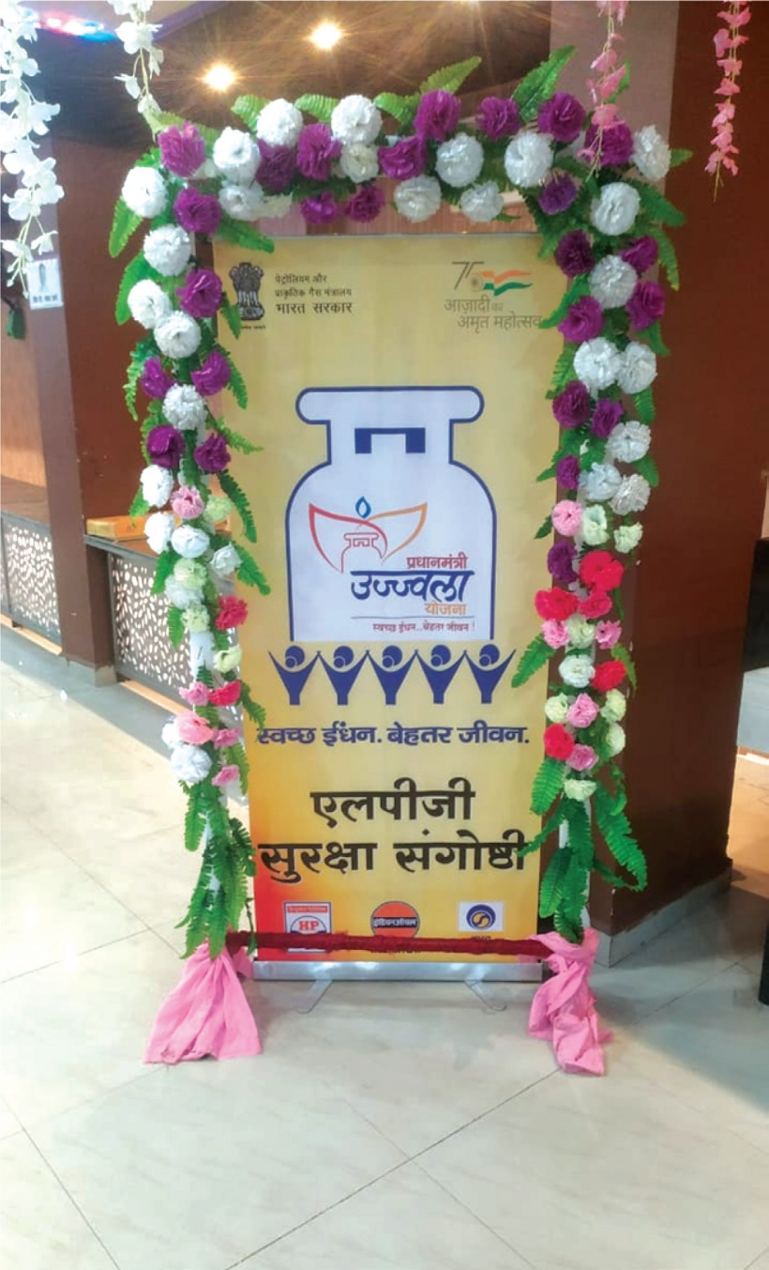
Ujjwala Program Conducted in presence of 350 participants and around 600 participants connected Live through YouTube Virtual mode.
Awareness program conducted on Ujjwala on below topics:
a) Brief on Ujjwala – 2.0 scheme
b) Do’s and Don’ts of LPG installation
c) Emergency measures in case of leakage
d) LPG Conservation tips

Participants appreciated the
program and 5 Ujjwala Beneficiaries
gave insights about how life has changed after Ujjwala Benefit.
We sincerely thank HQ, Region & State for their guidance and Support
for making the event great success.


