IOCL LPG Suraksha Sangoshthi, 03.06.2022
An Awareness programme “LPG Surakasha Sangoshthi “Under Azadi Ka Amrit Mahotsav was conducted at Jammu in which Hon’ble Mayor Shri Chander Mohan Gupta Jammu Municipal Corporation, Hon’ble Deputy Mayor Adv. Purnima Sharma, Jammu Municipal Corporation and 200 Ujjwala Beneficiary participated. Under the program, women associated with the Ujjwala scheme were taught the nuances of using LPG cylinders. Inputs on how to conserve LPG and safe handing and usage of LPG cylinders were deliberated to Ujjwala Beneficiaries. They were also made aware about using standard BIS approved Hose pipes and Pressure regulator and replacing the hose pipe after 5 years in use. When LPG gas cylinder is not in use, it should be turned off. At the end, free Hose pipe were also distributed to all the Ujjwala Beneficiary in attendance.
Divisional Retail Sales Head and SLC, IOCL, Shri Anjani Kumar, Divisional LPG Head, IOCL, Shri Ajay Kumar Wazir, Territory Manager-LPG, BPCL Shri Sandeep Kumar Raina, Deputy General Manager, HPCL Shri Nikunj Kumar Shukla and other OMC’s officers also attended the event.

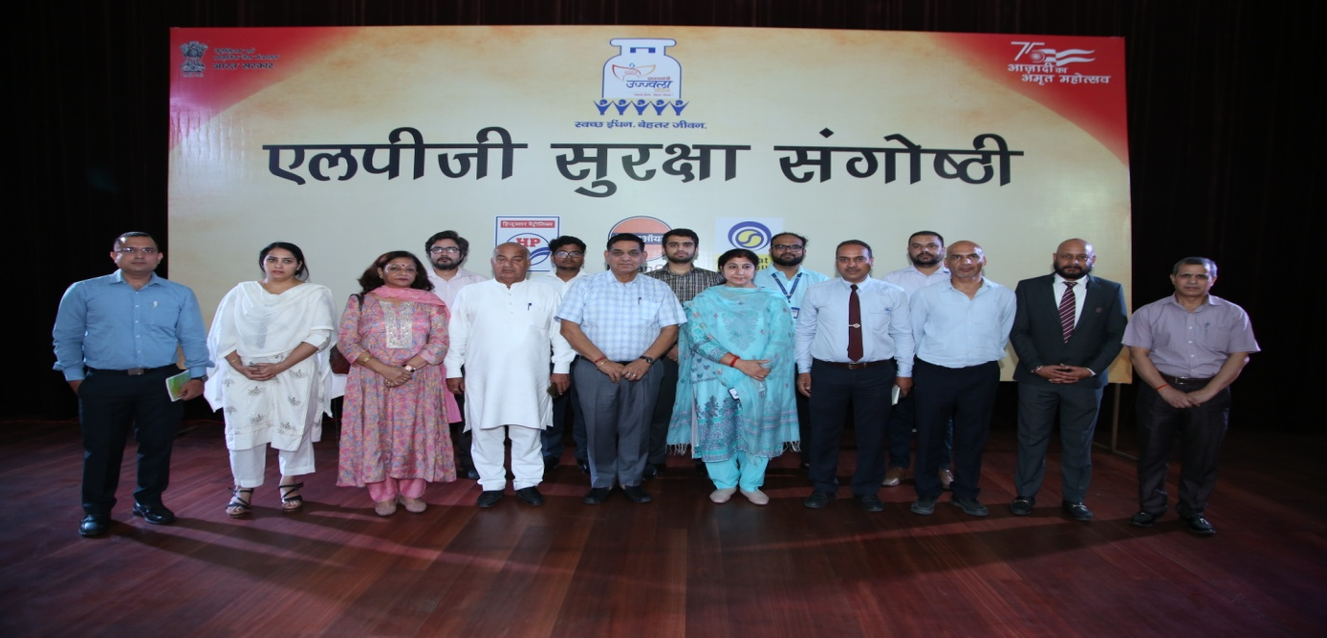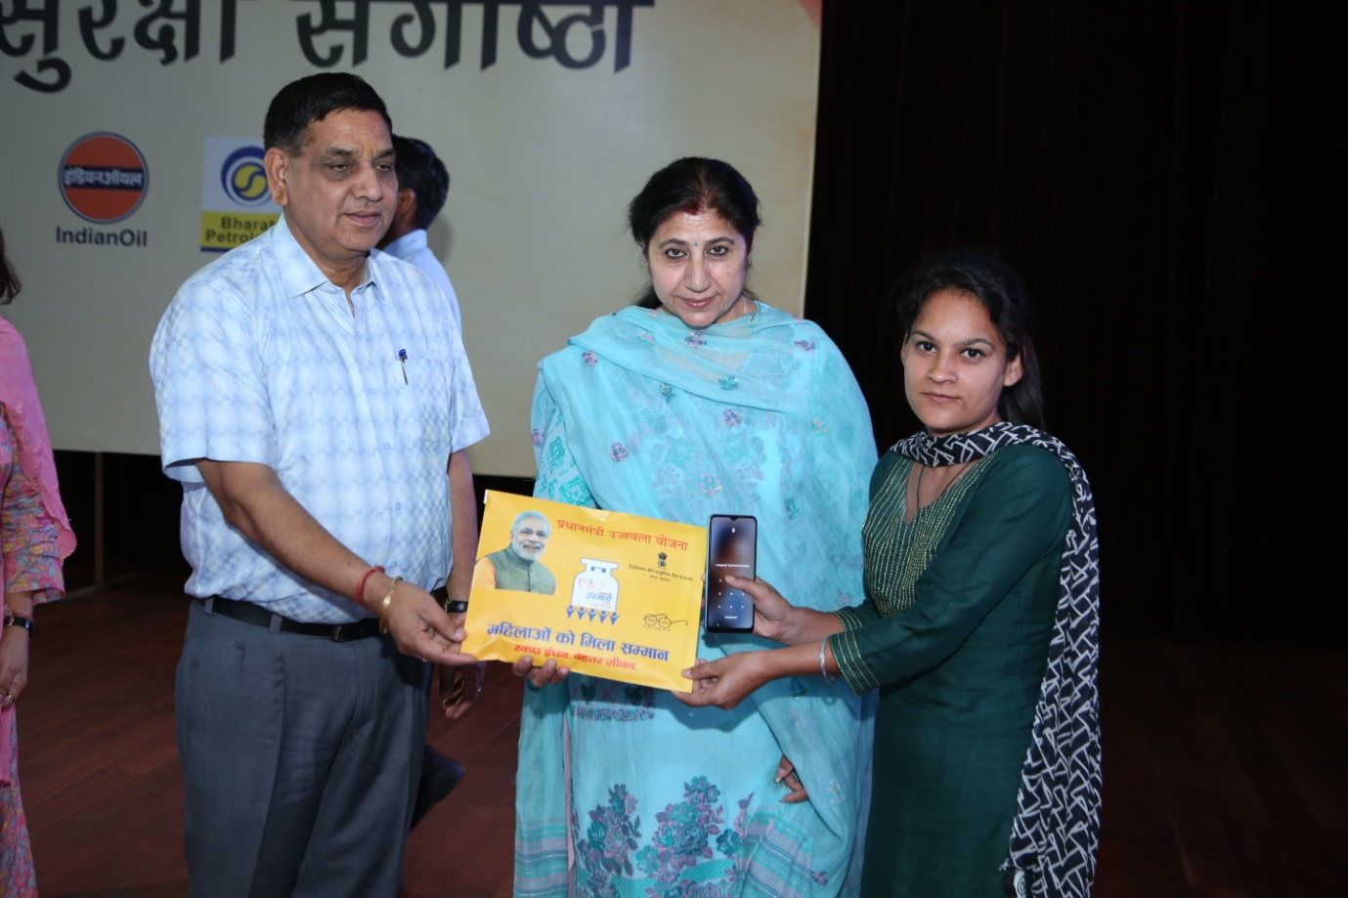

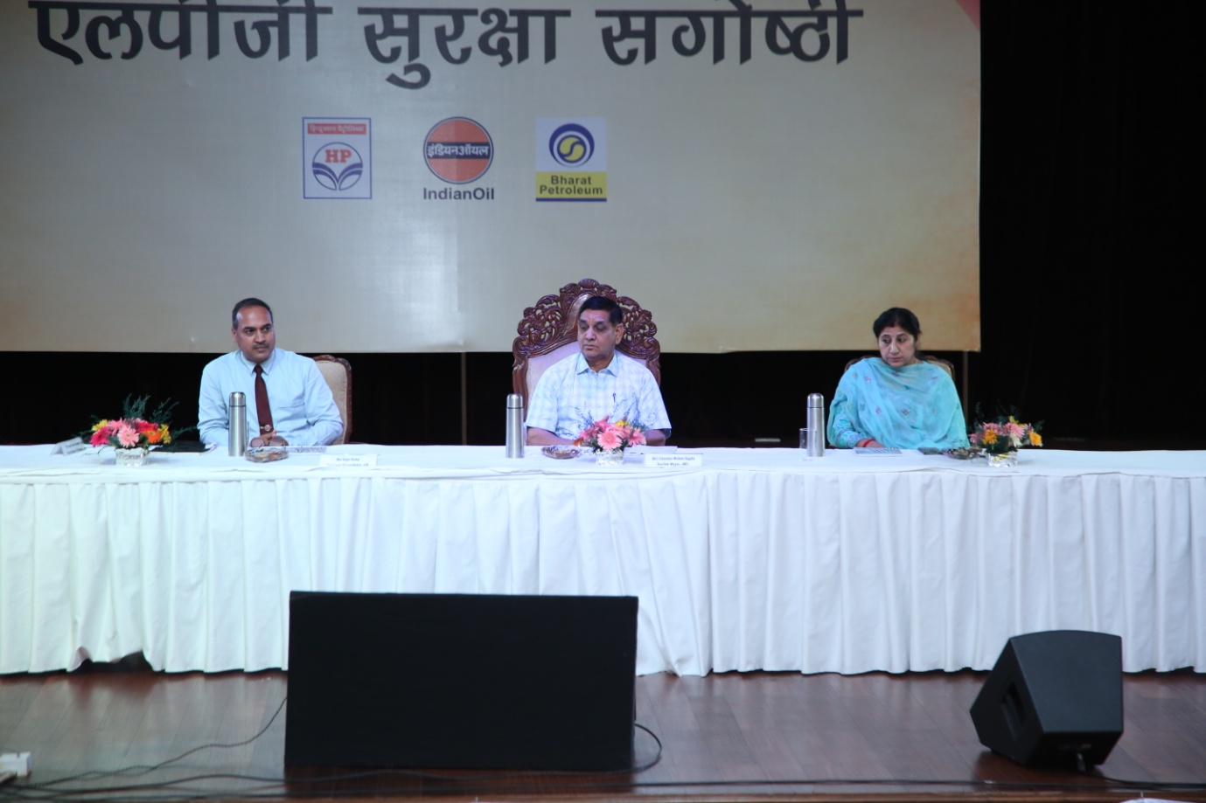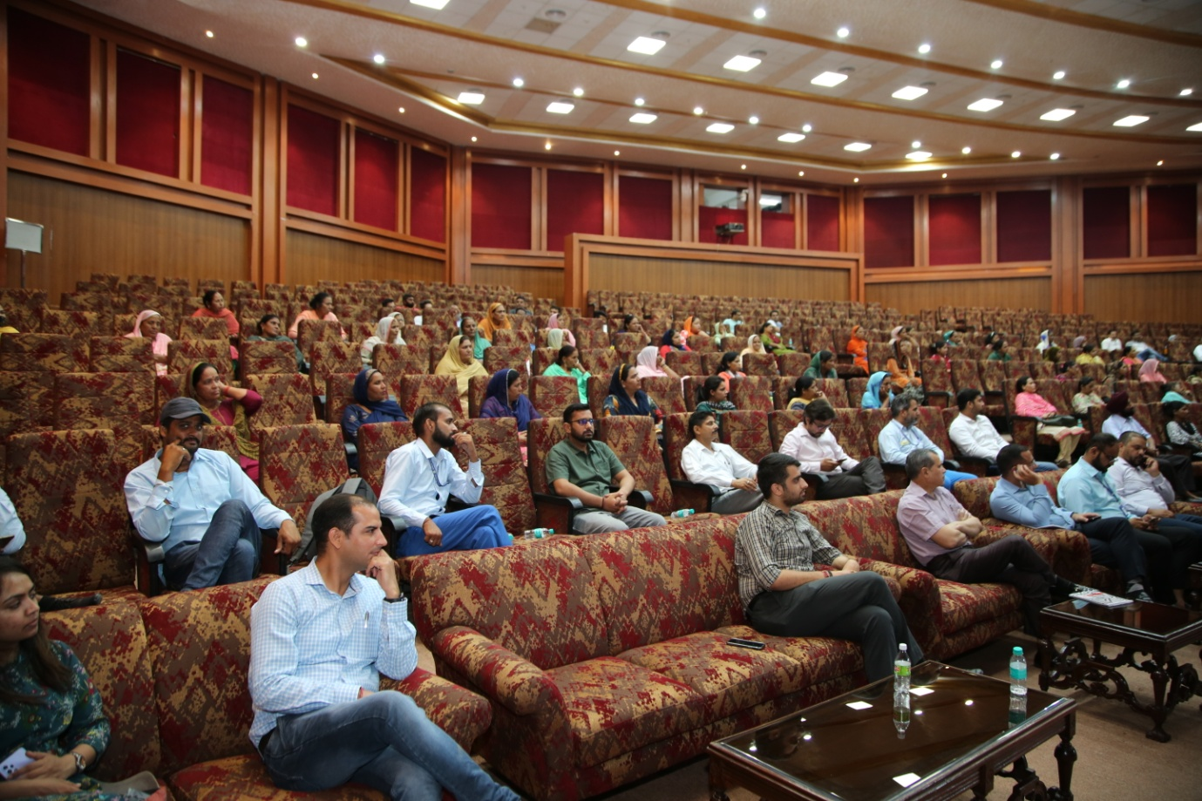

OIL organized study visit of students under AKAM on 28th May, 2022

Oil India Limited (OIL) organised a study visit for school students to a Sucker Rod Pump of OIL in one of its operational areas at Duliajan as part of the Azadi Ka Amrit Mahotsav celebration.
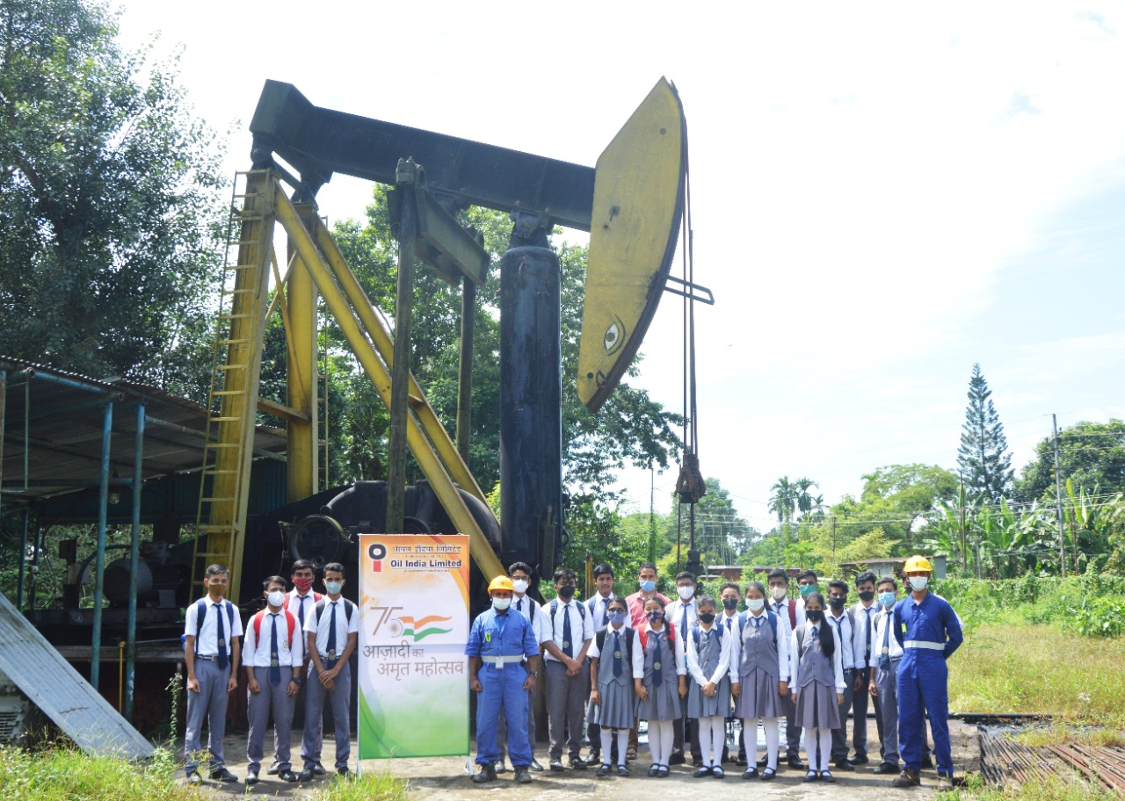
Production Engineers from Oil India Limited explained to the students the functions of a rod pump. The engineers explained to the students about the artificial lift technique in a well that provides mechanical energy to lift oil from bottom-hole to surface. The students were explained how efficient, simple, and easy the technique is for field people to operate and can be used to pump a well at very low bottom-hole pressure to maximize oil production rates.

