IOCL LPG Suraksha Sangoshthi, 06.06.2022
An Awareness programme on LPG under Azadi ka Amrit Mahotsav was conducted in Leh LPG BP in which Chairman/CEC, LAHDC Leh, Adv. Tashi Gyalson, MP Ladakh, Jamyang Tsering Namgyal, Dy Secretary (Gen.) Ministry of Petroleum & Natural Gas, Arvind Jha, Senior and other officers of IOCL participated.
CEC Tashi Gyalson alongwith MP Ladakh appreciated IOCL for conducting the programme and further stressed the need for having an effective plan for transporting LPG Cylinders during refilling to remote regions of Ladakh to reduce additional stress and cost for such people. He also spoke of PM’s vision of making Ladakh carbon-neutral and sought assistance from stakeholders like IOCL in sorting out alternatives for effective fuels for heating systems during the harsh winter season in Ladakh.
Dy Secretary (Gen.) Ministry of Petroleum & Natural Gas, Arvind Jha had a detailed interaction with the beneficiaries about various Govt. schemes.
Senior Sales Manager IOCL, Rakesh Roshan, Assistant Director CA PD Leh, Ruth Mary, Manager LPG-S, Mohammad Salah Ud Deen, and Plant Manager, Ashu Agarwal also attended the event.

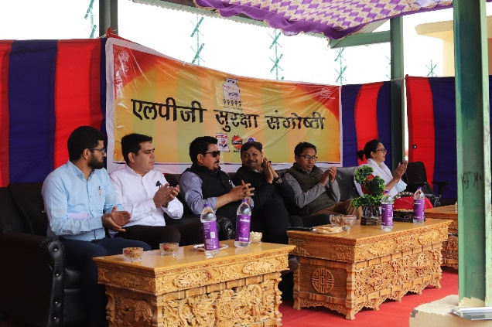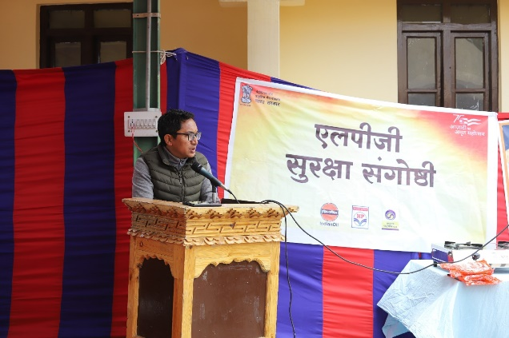

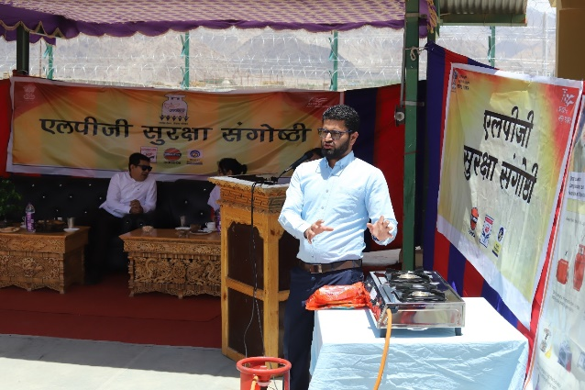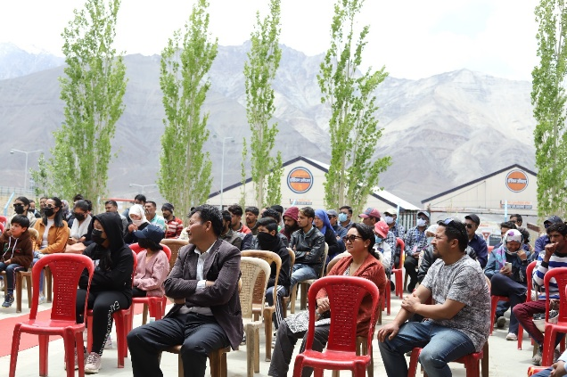

HPCL organized Biofuel Exhibition at Jamshedpur on 10.06.2022

HPCL organized the Bio-fuel exhibition on 10.06.22 at Jamshedpur. HPCL, IOCL, BPCL, GAIL & GGL participated actively to make this exhibition a grand success.
Chief Guest Sh. K C Choudhary (Controller, W&M Dept., Govt. of Jharkhand) inaugurated the exhibition at 10:00 AM at Sonnet Hotel, Jamshedpur.
Ch. Guest delivered the speech and spread the awareness about the ambitious vision of our Honorable Prime Minister in making the country self-sufficient and how use of Bio-fuel will get this country a step closer to this ambition. Ch. Guests also appealed the gathering to not to use the cooking oil twice and emphasized its bad effect on human health, in addition, how it can be converted to Bio-diesel.
He also emphasized on the opportunity of producing 2G ethanol from biomass. Since biomass (rice husk, straw) production in Jharkhand is in abundance, setting up of 2G Ethanol plant in Jharkhand will be a great opportunity. It will also curtail the problem of stubble burning.
Dealer fraternity of OMCs witnessed the event along with other stakeholders like student from college and normal public from Jamshedpur city.
3-D prototype model of 1G Ethanol production plant and 1TPD Bio-diesel production plant were the focus attention points of the visitors.
HPCL closely coordinated with all stake-holders – including OMC officials, Govt. functionaries as well as dealer / transporter fraternity for making this exhibition a successful event. These included –

- HPCL arranged to transport 3-D prototype models of 1G Ethanol production plant and 1TPD Bio-diesel production plant from Kolkata to Jamshedpur, and the models were explained in detail to the interested participants.
- We coordinated with HPCL Retail Team at Ranchi to invite key Jharkhand govt. officials.
- A detailed presentation was also given wherein status of Ethanol blending program as well as new initiatives was briefed to all the participants.
- HPCL officers from Bokaro IRD, Ranchi retail RO, LPG RO, DSRO also witnessed the event.
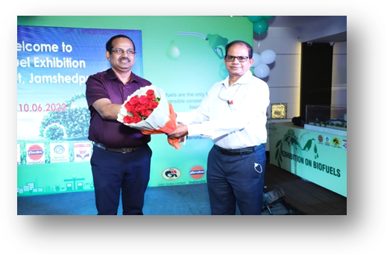
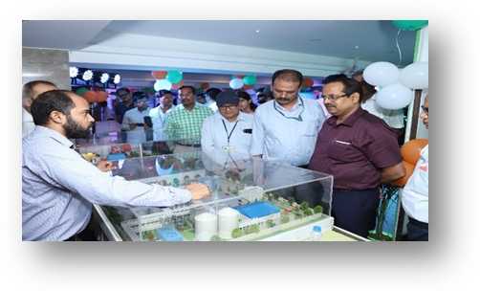
Few Photographs from the exhibition are displayed below:


